How Bayesian Statistics Is Related To Machine Learning?

Explain The Strength Of Bayesian Statistics

What Are Some Unique Applications Of Bayesian Statistics And Bayes Theorem?

Explain The Inconsistencies In Bayesian Inference.

Explain The Difference Between Bayes Theorem And Conditional Probability

What are the Types of Naïve Bayes Classifier?

What are the Advantages of Naïve Bayes Classifier?

What are the Applications of Naïve Bayes Classifier?

What are the steps to implement Naïve Bayes algorithm in Python?

Why Bayesian Statistics Is Important?

Solutions:
1) 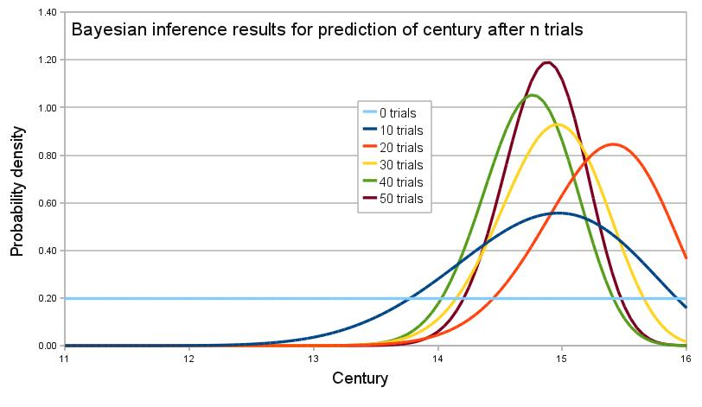
Machine learning simply tries to predict something about a certain system based on data available. But Bayesian statistics, on the other hand, is the degree of belief.
Bayesian machine learning is useful when there are fewer data available. So, using this method, it is predicted what the model will look like based on prior knowledge.
2)
- Bayesian gives intuitive and direct inferences. It meaningfully tells the probability of a hypothesis being true.
- Introduction to Bayesian statistics enhanced the power of answering complicated questions easily and clearly.
- Bayesian uses every available information to find the probability. This indicates that apart from data, the method uses prior information as well.
- The method enhances decision-making. When there is a lack of parameters and facts, Bayesian quantify uncertainties using available evidence.
3) There are various unique applications of it and Bayes theorem. Here are some of these:
- It can be used to decide whether a project will finish on time or not? There are only two possible outcomes, either it will finish on/before time or it will not.
- Using multiple blood samples to decide diseases.
- Utilizing it as a spam filter considering previous patterns.
- It is used to detect whether a certain water body is fit for various purposes such as drinking, agriculture, etc. Since, due to the presence of various pollutants, it is not possible to give an exact quantifier, the Bayesian method is used.
4) There are various loopholes in Bayesian inference:
- In most real-world examples, obtaining the prior probability is often hard.
- When both prior and likelihood become too complicated, MCMC (Markov chain Monte Carlo) sampling is used. This is extremely slow in real instances.
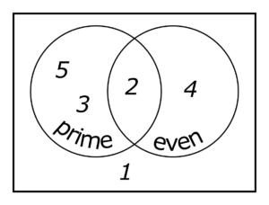
- In order to quantify the prior knowledge, the user can influence the result, unknowingly or knowingly.
5)

Conditional probability finds the probability of an event A in accordance with the occurrence of other event B. It is represented as:
P(A|B) = P(A∩B)/P(B)
P(A∩B) is the probability of both A and B occurring at the same time.
P(A/B) is the probability of occurrence of A when B has already occurred.
6) a. Multinomial Naïve Bayes Classifier:
Feature vectors represent the frequencies with which certain events have been generated by a multinomial distribution. This is the event model typically used for document classification.

b. Bernoulli Naïve Bayes Classifier:
In the multivariate Bernoulli event model, features are independent booleans (binary variables) describing inputs. Like the multinomial model, this model is popular for document classification tasks, where binary term occurrence (i.e. a word occurs in a document or not) features are used rather than term frequencies (i.e. frequency of a word in the document).

c. Gaussian Naïve Bayes Classifier:
In Gaussian Naïve Bayes, continuous values associated with each feature are assumed to be distributed according to a Gaussian distribution (Normal distribution). When plotted, it gives a bell-shaped curve which is symmetric about the mean of the feature values as shown below:

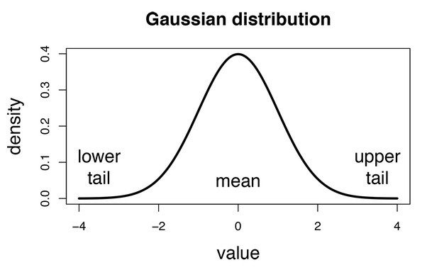
The likelihood of the features is assumed to be Gaussian, hence, conditional probability is given by:

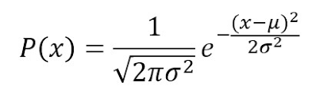

7)
- Naïve Bayes is one of the fast and easy ML algorithms to predict a class of datasets.
- It can be used for Binary as well as Multi-class Classifications.
- It performs well in Multi-class predictions as compared to the other Algorithms.
- It is the most popular choice for text classification problems.

8)
- It is used for Credit Scoring.
- It is used in medical data classification.
- It can be used in real-time predictions because Naïve Bayes Classifier is an eager learner.
- It is used in Text classification such as Spam filtering and Sentiment analysis.
9) Steps to implement:
- Data Pre-processing step
- Fitting Naive Bayes to the Training set
- Predicting the test result
- Test accuracy of the result(Creation of Confusion matrix)
- Visualizing the test set result.
10) It is fundamentally sound and at some times, highly useful.
In addition, it uses the rigid format of the likelihood of the outcome and prior knowledge of a possible situation. Then, the posterior probability is calculated. This rigid nature of the method sometimes helps in solving complex models.
In addition, it is really essential in some instances because it quantifies a degree of belief. Hence, it can quantify and find the probability of if a certain belief is true or not. If we look at frequentist statistics, it can only quantify events and not a hypothesis.

